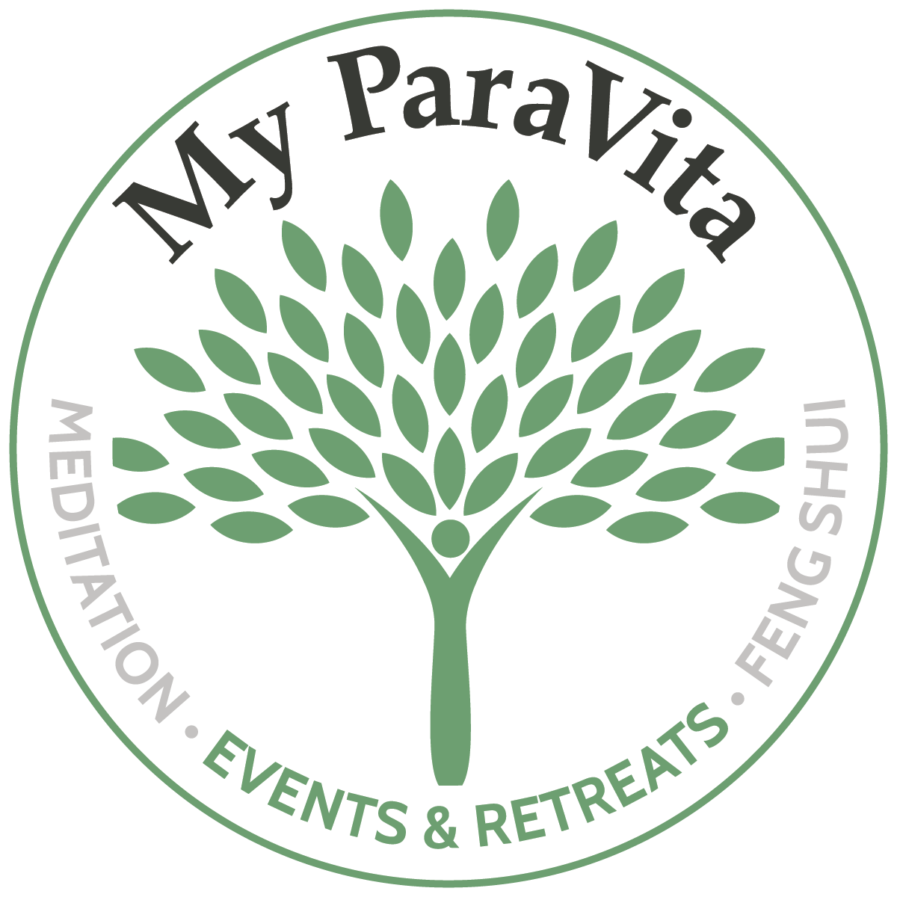

Spirit Talk: Mysteries of the Feminine
Registration Form

Laura Heselton & Kristi Stangeland
May 16-23, 2020 Domaine De Mournac. Antugnac, France

Personal Information
Full Name (exactly as shown on passport):
Date of Birth (mm/dd/yy):
Address: |  |  | City: |  | Postal Code:
Telephone:
E-mail Address:
Are travelling alone or with a friend/partner?
If travelling with someone, please enter full their name:
Emergency Contact Name:
Emergency Contact Phone Number:
Emergency Contact E-mail Address:

Health Information
Dietary restrictions/allergies:
Please disclose any relevant heath/medical conditions:

Accommodation Selection: (Please indicate choice with ‘X’)

Shared Room (2 Per Room) |  | Single Room (SOLD OUT)
$2,900.00 USD per person - double occupancy |  | $3,500.00 USD per person - single occupancy  (SOLD OUT)

Payment
- A non-refundable deposit of 600.00 USD is required to reserve your spot.
- Balance to be paid in full by April 1, 2020
- Credit card and USD cheque are accepted.

To book, please contact travel partner Cathy Wassermann from Wassermann Retreats an affiliate of Vision Travel Inc. (TICO #50023504)

e-mail: cathy.wassermann@visiontravel.ca // phone: (289) 344-0089

Flight / Travel Arrangements

Please ensure you have a passport that is valid for at least 6 months from date of travel.

To take advantage of the group transfer your flight must arrive into Toulouse airport by 12pm on May 16th. The departing flight should be no earlier than 9am on May 23rd. Please do not book your flights until we advise you that our minimum number of participants has been reached.

Insurance

Cathy can assist with flight bookings and trip/medical insurance.

Note: Trip travel insurance protects you against financial losses suffered due to unexpected trip related situations like
trip cancellation, trip interruption, trip delay, missed flight connection, baggage loss.

Medical Insurance protects you against unforeseen health issues met while you are traveling; which includes
sickness, injuries, and accidents. Note that we can only offer out of country medical insurance to Canadian Citizens.

Please indicate below if you would like a quote (‘X’ where applicable):

I would like a quote for cancellation ___ and or medical insurance ___

*Reminder that retreat payments are 100% non-refundable.

I decline cancelation insurance Signature _______________________________

I decline medical insurance Signature _______________________________

Included in pricing
- Transfer to and from Toulouse airport
- 4 Guided Meditation Sessions
- All breakfasts and dinners and 3 lunches
- Wine tour
- Guided tours to the following:
  - Alet – Rennes-Le-Chateau
  - Rennes-les-Bains
  - Ste Marie de la Mer
  - Mirepoix

Not included in pricing
- airfare & travel insurance
- optional excursions and spa services
- alcoholic beverages
- staff gratuities

Acknowledgement

I have read and understood the information contained in this registration form. I hereby affirm that I am in general good health and have not been diagnosed with any conditions that would jeopardize me or any other members of this retreat. I take full responsibility for any injuries I may sustain or damages I may incur in participating in this program. I will indemnify Kristi Stangeland and Laura Heselton from any costs, losses or damages directly or indirectly caused by my actions during this retreat. I understand that this retreat is non-refundable.

Signature: |  |  | Date:

